**Bkg Electro Fab**

**Demo**

**Slide 1**

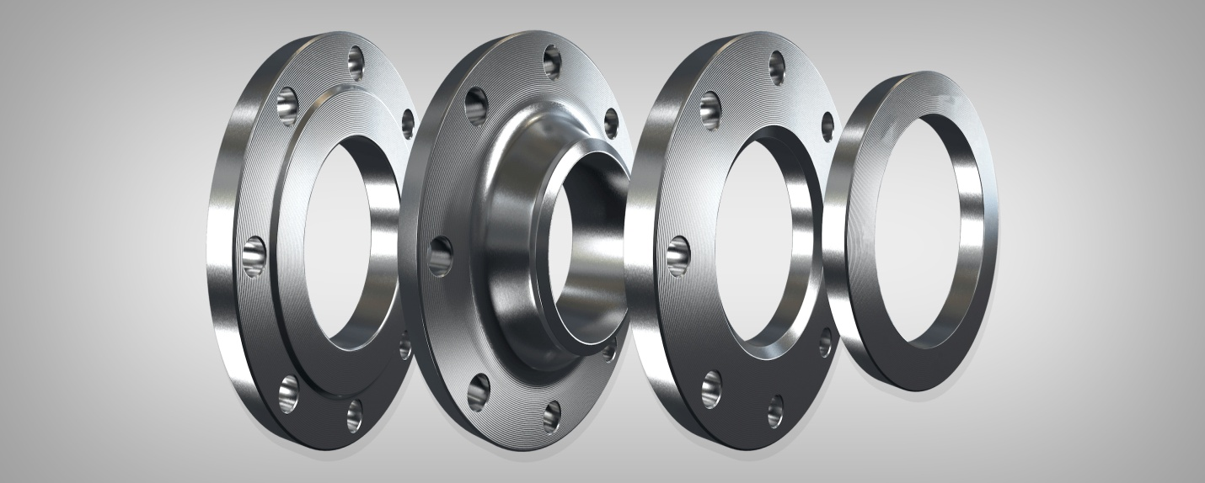

**Slide 2**

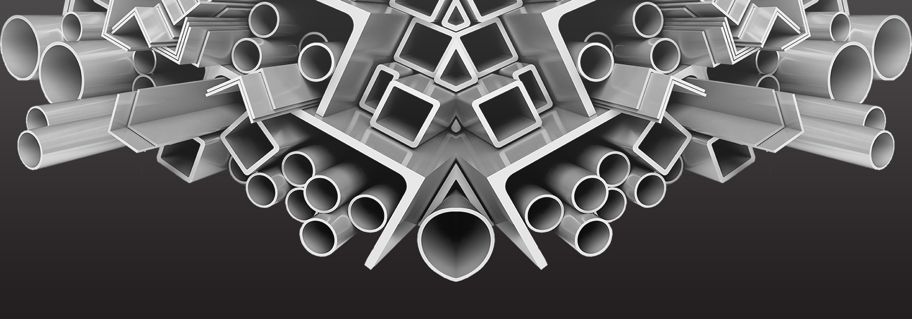

**Slide 3**

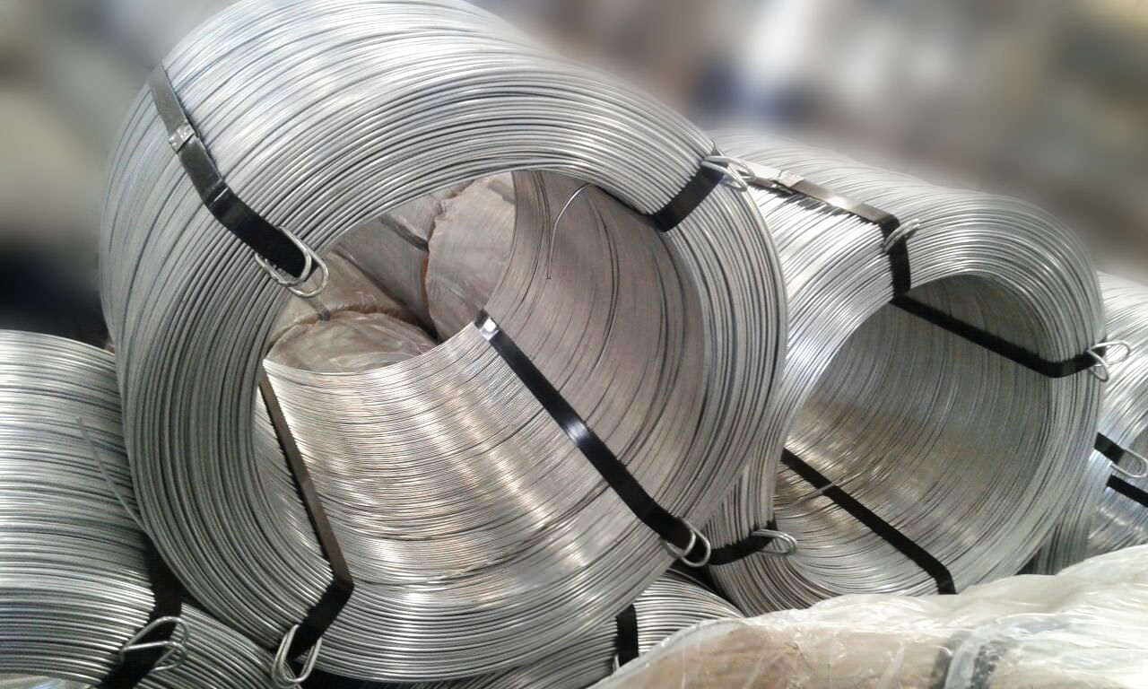

**Slide 4**

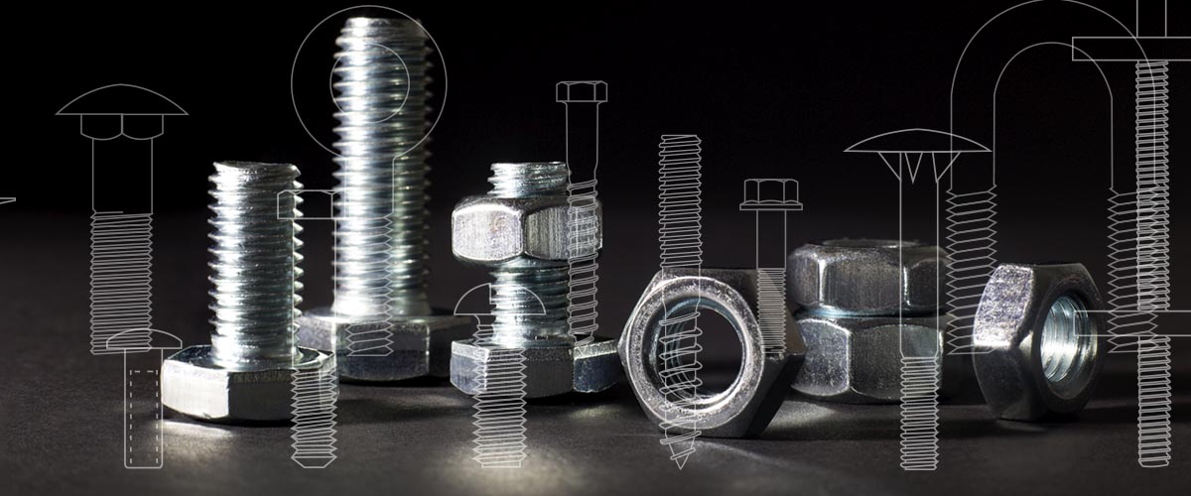

**Slide 5**

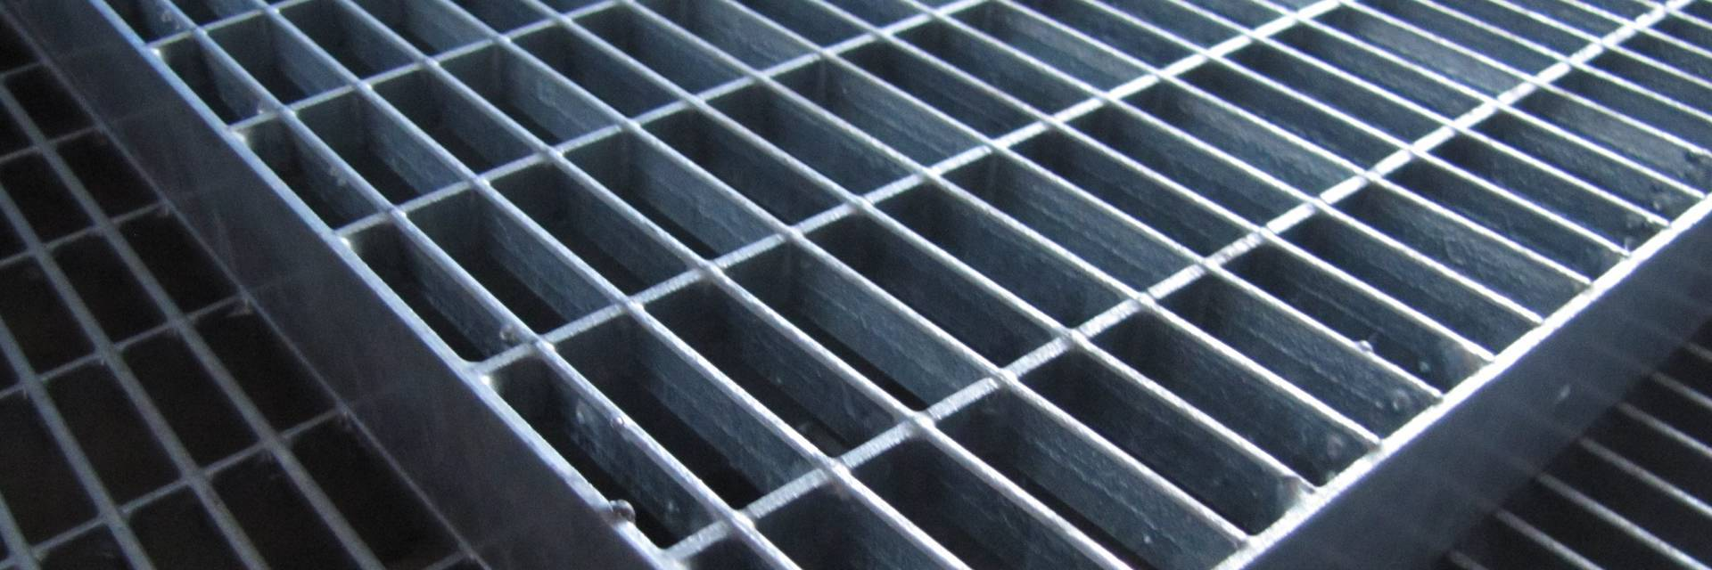

**Welcome to** **Bkg Electro Fab**

Founded in the year **2016**, **Bkg Electro Fab** has carved a remarkable niche in market and known for its quality work. We are working as a **sole proprietorship** based firm. The head office of our company is situated at **Kolkata, West Bengal**. We are foremost **manufacturer** and **trader** of **Metal Flange, Metal Bolt, Metal Angle**and**Industrial Gasket**. These products are examined by our team before the final dispatch.

**Product**

**Metal Flange**

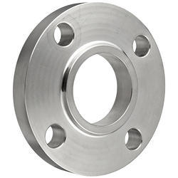

## Metal Angle

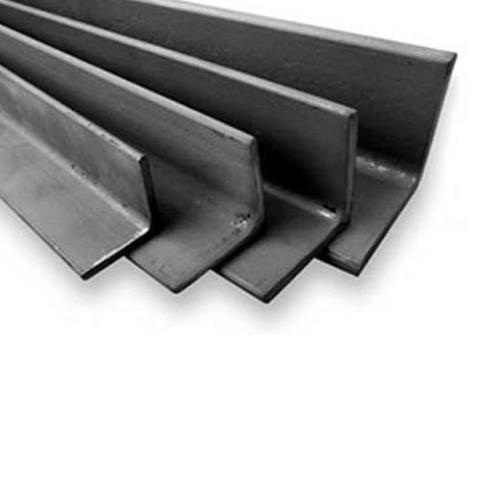

## Metal Bolt

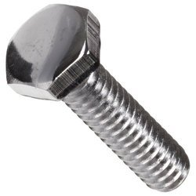

## Industrial Gasket

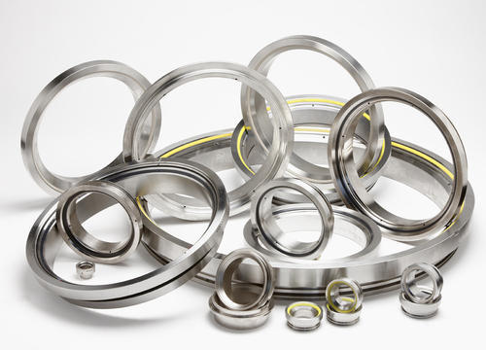

## Stainless Steel Grating

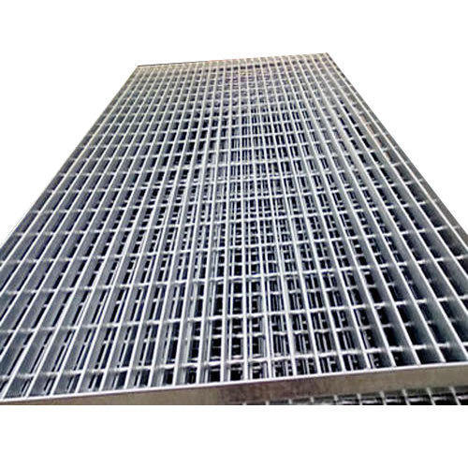

## Binding Wire

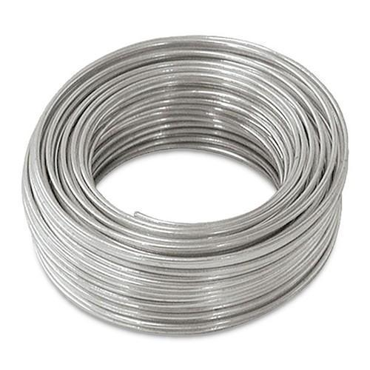

**Contact Us**

No. 309 BB, Ganguli Street, Room No. 7, 1st Floor,  
Kolkata-700012, West Bengal, India

**Branch Office**

**R SINGHANIA**  
8-B, 611 NEW MHADA COLONY, MAHAKALI ROAD, ANDHERI EAST, Mumbai City, Maharashtra, 400093  
India